**Wilson, Alex**

**CS214 – Database Technologies**

**HOP NUMBER 07A**

**Part 1**

**SCREENSHOT #1**

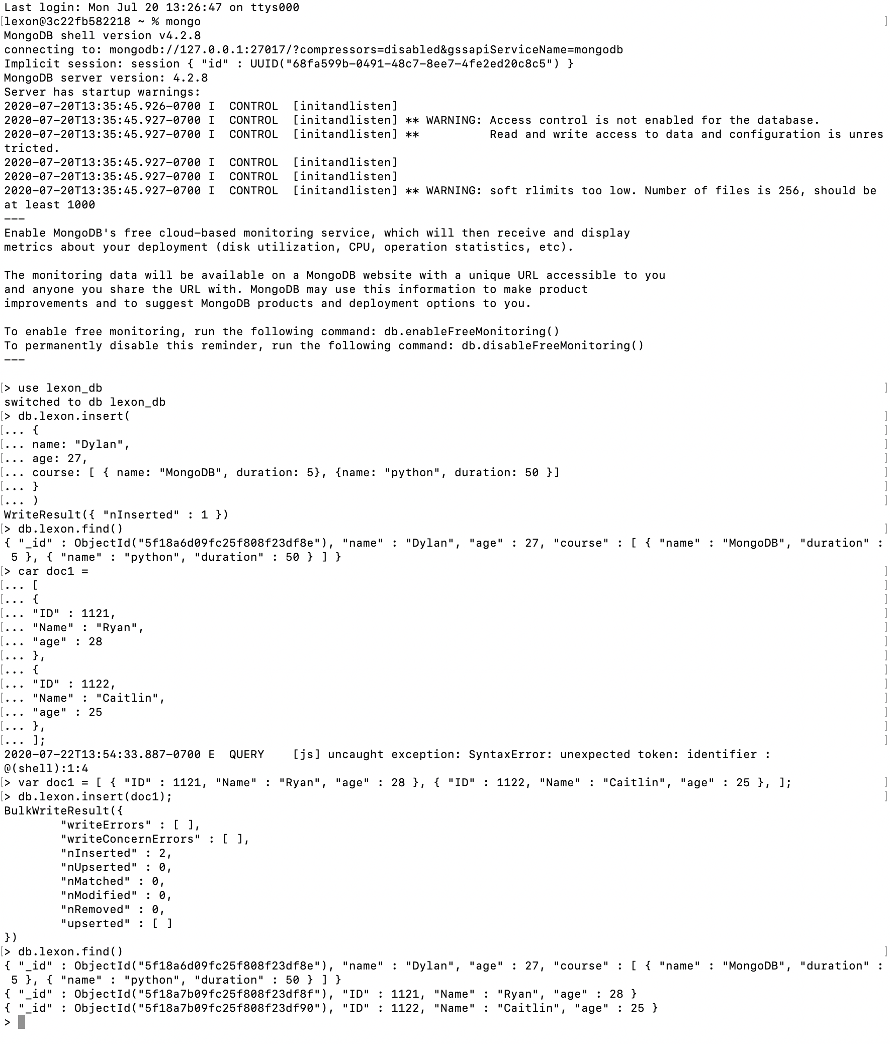

**SCREENSHOT #2**

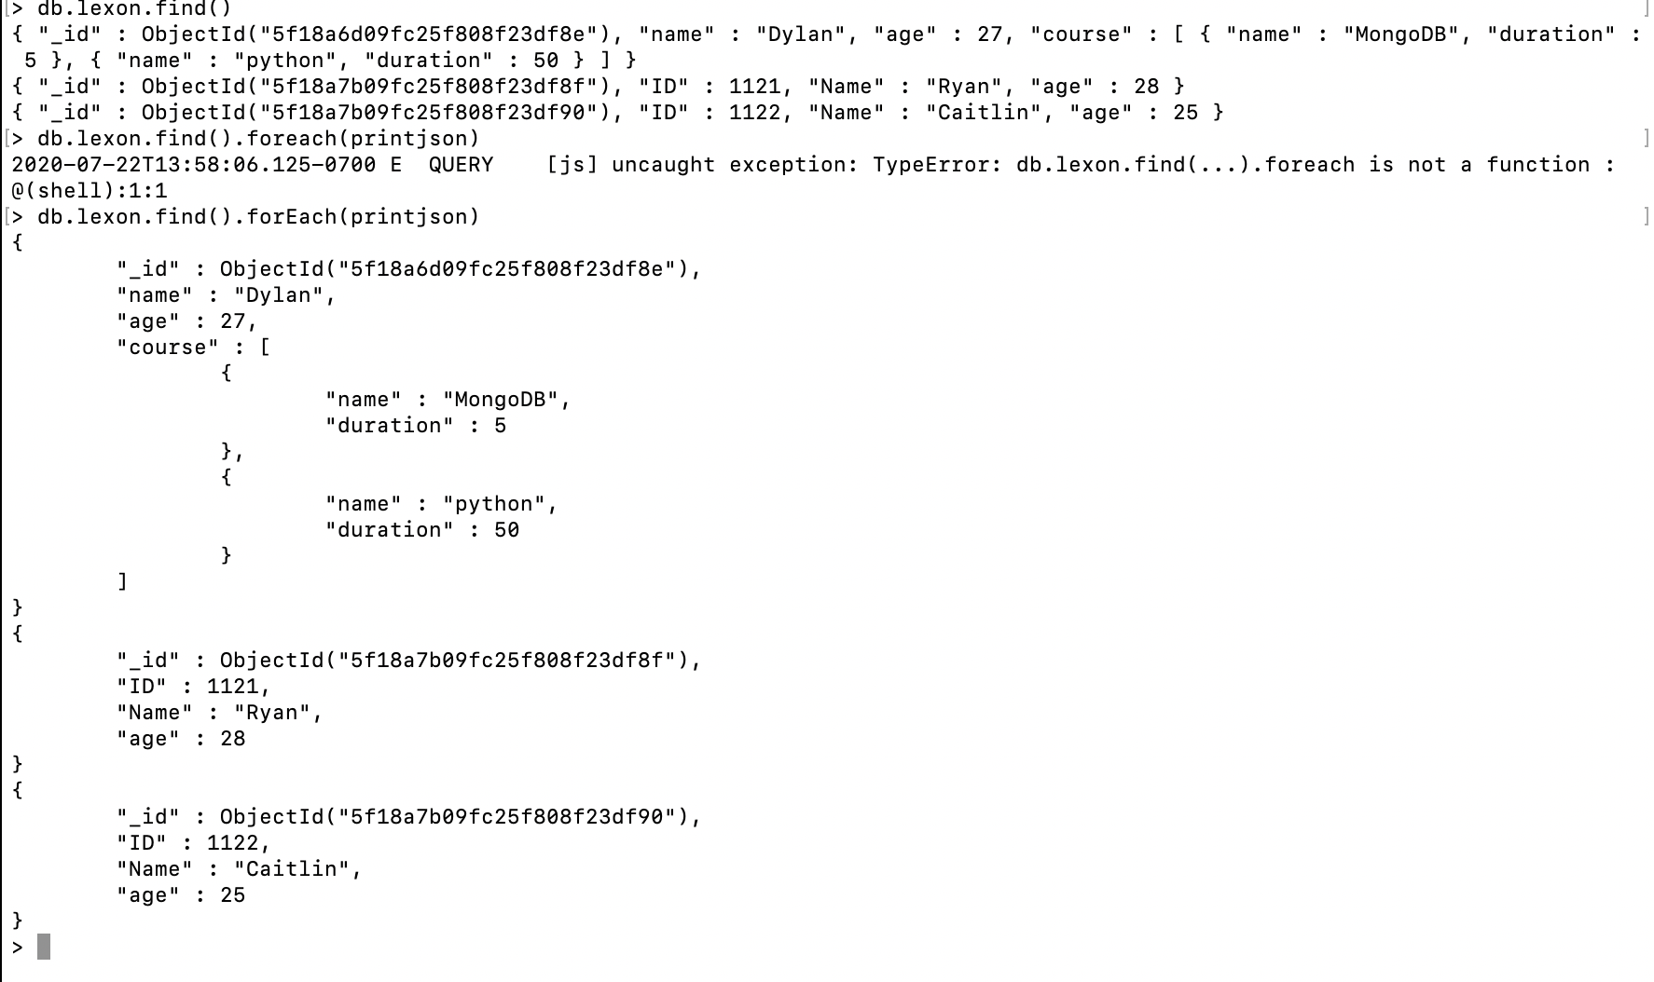

**SCREENSHOT #3**

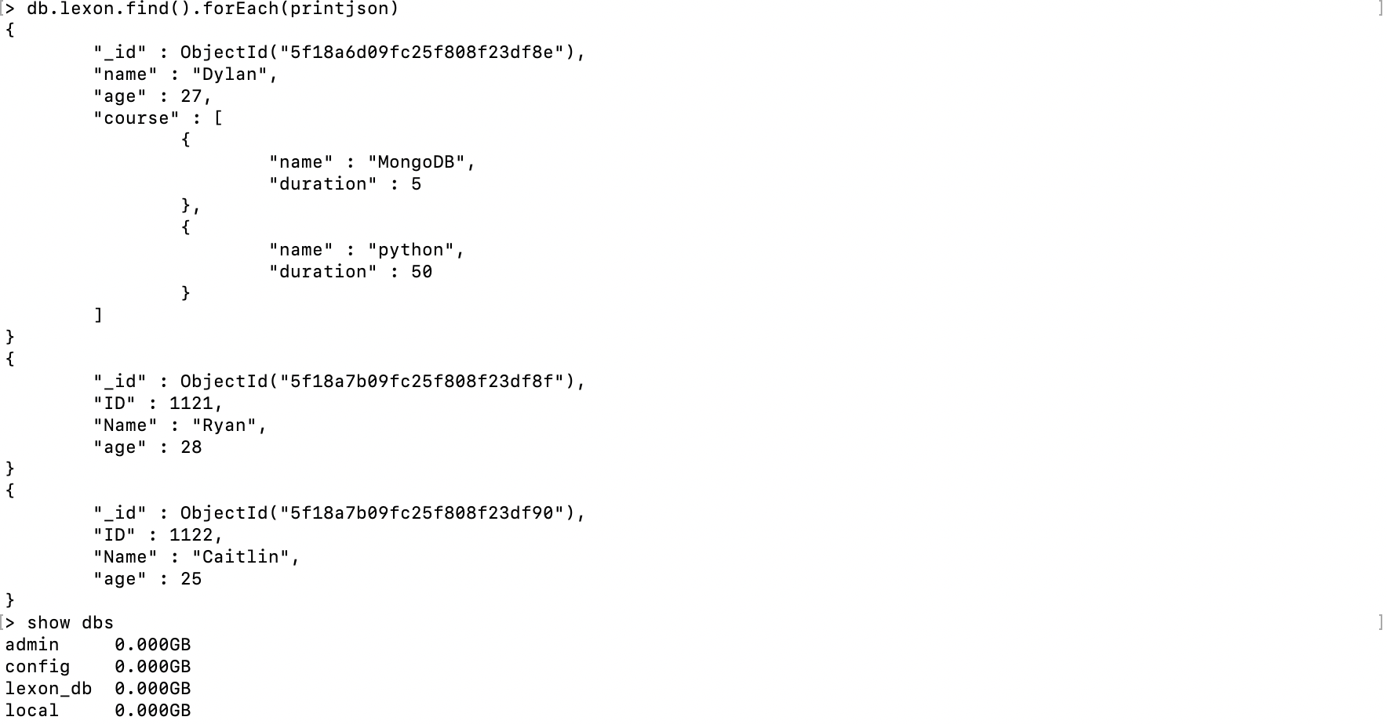

**PART 2**

This Hands-on Practice demonstrated manually inserting a document into your collection in Mongo DB.

The first step was to create the database. I created ‘lexon_db’.

use lexon_db

Next was to use the insert statement to insert the data into ‘lexon’:

> db.lexon_db.insert(

... {

... name: "Dylan",

... age: 27,

... course: [ { name: "MongoDB", duration: 5}, {name: "python", duration: 50 }]

... }

... )

In the information section, a user was created with their name, age and course information. Confirmation of the insertion comes by way of the message:

WriteResult({ "nInserted" : 1 })

The second portion of the exercise demonstrated created a document and then inserting the same kind of information as a document. To create the document:

> var doc1 =

... [

... {

... "ID" : 1121,

... "Name" : "Ryan",

... "age" : 28

... },

... {

... "ID" : 1122,

... "Name" : "Caitlin",

... "age" : 25

... },

... ];

The document contains information for two users and their respective ID’s, names and ages. Once the document is created, you can insert the document into the database:

> db.lexon_db.insert(doc1);

You should received a confirmation that looks like:

BulkWriteResult({

"writeErrors" : [ ],

"writeConcernErrors" : [ ],

"nInserted" : 2,

"nUpserted" : 0,

"nMatched" : 0,

"nModified" : 0,

"nRemoved" : 0,

"upserted" : [ ]

})

But to verify insertion, you can simply type:

db.lexon_db.find()

Or to display the output in JSON format:

> db.lexon_db.find().forEach(printjson)